Chemistry Depth Study

|  |  |  |  |  |  |  |  |
| --- | --- | --- | --- | --- | --- | --- | --- |
|  | **Table Salt** | **Sodium** | **Chlorine** | **Sucrose** | **Carbon** | **Hydrogen** | **Oxygen** |
| Appearance | Colourless or cloudy (white) crystals varying in shape and size but relatively small granules, under 1 mm averagely | Sliver- White coloured metal | Yellow – Green gas | Colourless crystals (White if bleached) varying in shape and size but are extremely fine granules, under 0.5 mm averagely | (Graphite) Black, shiny, and brittle rock.  (Diamond) Clear, hard and colourless gem. | Colourless, Odourless and tasteless Gas. | (Gas) Colourless (liquid) Pale Blue |
| Atomic Symbol | NaCl | Na | Cl | CHO | C | H | O |
| Mass Number | Molecular weight – 58.45 | 22.99 | 35.45 | 342.3 Grams per Molecule | 12.01 | 1.00 | 15.99 |
| Atomic Number | N/A | 11 | 17 | N/A | 6 | 1 |  |
| Position in periodic table | N/A | 1st Column, 2nd Row. Grouped with Alkali Metal | 17th Column, 2nd Row. Grouped with Other Non-Metals | N/A | 14th Column, 2nd Row. Grouped with Other Non-Metals | 1st Column, 1st Row. Grouped with Other Non-Metals | 16th Column, 2nd Row. Grouped with Other Non-Metals |
| Composition and formula | Lattice in a  1 sodium ion : 1 chlorine ion ratio | N/A | Diatomic  Cl₂ | C₁₂H₂₂O₁₁ Molecule | Multiple | Diatomic  H₂ | Diatomic  O₂ |
| Melting Point | 801°C | 97.79°C | -101.5°C | 186°C | 3825°C | -259.2°C | -218.8°C |
| Density | 2.165 Grams per Cubic Centimetre | 0.97 Grams per cubic Centimetre | 3.214 Grams per Litre | 1.587 Grams per Cubic Centimetre | 2.26 Grams per Cubic Centimetre | 0.0899 Grams per Litre | 1.429 Grams per Litre |
| Hardness | 2 on the Mohs Scale | 0.5 on the Mohs Scale | N/A on the Mohs Scale | 1.5 on the Mohs Scale | 0.5 on the Mohs Scale | N/A on the Mohs Scale | N/A on the Mohs Scale |
| Physical state at room temperature | Solid | Solid | Gas | Solid | Solid | Gas | Gas |
| Lewis dot diagram | Image result for sodium chloride lewis dot structure | Image result for sodium lewis dot structure | Image result for chlorine lewis dot structure | Image result for sucrose lewis dot structure | Image result for Carbon lewis dot structure | Image result for Hydrogen lewis dot structure | Image result for oxygen lewis dot structure |

Structure

Table salt

As table salt consists of the Positive ionic charge of the sodium and the Negative ionic charge of Chlorine, the two for an ionic lattice. They form this bond due to the metallic atom being positively ionic (i.e. a Cation) and the non-metallic atom being negatively ionic (i.e. Anion) thus the two attract. Due the lattice formed, on a macroscopic level we observe salt to be crystals. This bond is known as an Ionic Bond.

Sucrose

Sucrose is a nonreducing disaccharide. Meaning the Sugar molecule cannot lend any electrons, and is also a combination of two Sugars. In this case Glucose and Fructose join together by forming aldehyde and ketone groups. These groups consist of Carbon atoms having to remaining bonds. If one of these two remaining bonds is shared with Hydrogen the group is known as Aldehyde, if not then it is classified as Ketone.

Question 3 Model 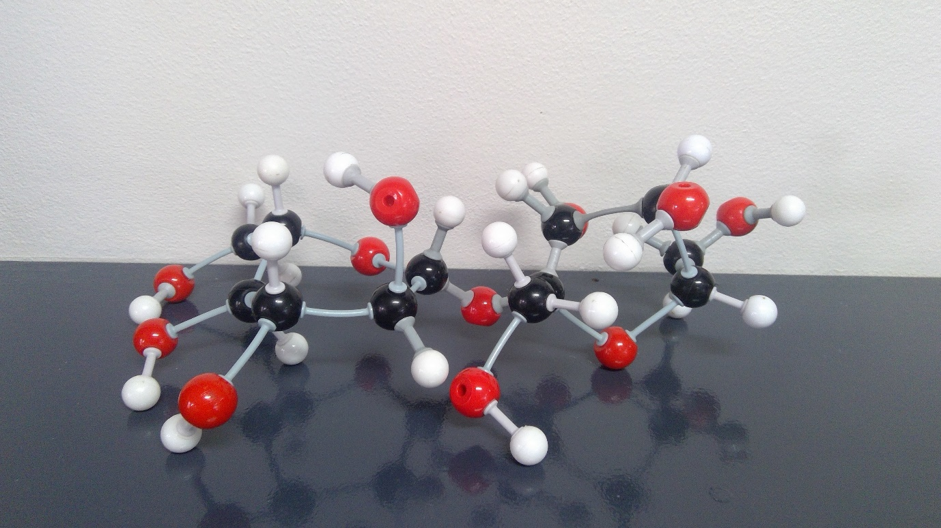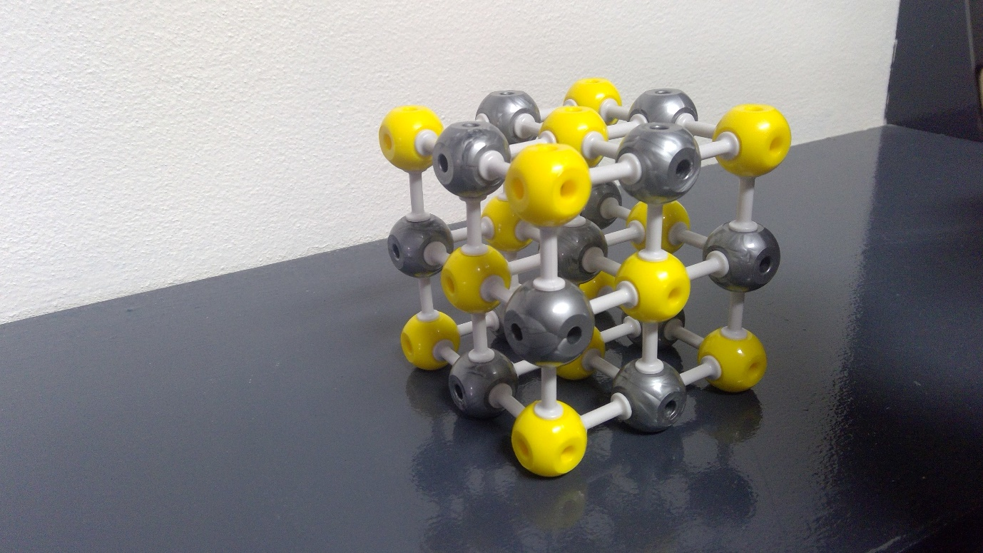

Commercial production of salt.

Salt is mass produced in two common methods. Either through sea salt collection or through mining rock salt. Starting off with sea salt, it originated by us collecting water in naturally concentrated areas called licks. But as these areas are not common we turned to evaporating ordinary sea water with the sun. A disadvantage to this is that it is suited to hotter climates. In other, cooler climates people had to resort to using fire to evaporate the salt but this was not efficient as it use a lot of resources. Later, in the 1860’s the Grainer process was invented. This system involved boiling salt water with a network of pipes heated by steam. After a few adjustments over two decades the process was made more effective by using alternate energy sources and a vacuum. This is the process we currently use now and has been largely unchanged for over half a century, with the only major adjustments being more effective energy sources. All over the world sea salt collection is carried out in all these methods, whether it be solar evaporation, or using fire or steam. But the most commonly used is the vacuum system. The only noticeable downside of this method is it consumes high amounts of energy compared to other methods but otherwise this is a chosen method due the high supply of raw materials.

The process of obtaining rock salt is relatively simple and has been dated back over two thousand year to the Chinese. The process involves drilling into areas of high salt concentration. These areas are concentrated due the previous existence of oceans. This mined salt is called halite. There are major disadvantages to this procedure as it takes expensive resources to find and extract the salt. Also the salt often has to undergo multiple mechanical and chemical processes to purify the salt as to meet health guidelines. This is due to the large presence of impurities that is not found in sea salt.

As a raw product, Sucrose can be found in a variety of plants. The most globally common for commercial use being the Sugar Cane. To start the process of extracting Sucrose from Sugar Cane it is harvested and sent to a refinery. The Cane is then put through a process of shredding to release the juice, using a machine called the large roller mill. Through chemical and mechanical processes the Cane is then clarified to ensure all impurities are removed. After various stages of filtration all the excess water is remove from the juice by evaporating it. The remaining juice is boiled and then Seed crystals are added. These help the formation of Sugar crystals. After that the Sugar is placed into a centrifuge as molasses, an unwanted element in Sugar, is removed and sold later as a sweetener. The now raw Sugar that is left, is melted into a syrup and further filtered. The Sugar is then coloured usually using some form of bleaching agent. The disadvantage of this process is it is long and thus not cost effective but using Sugar Cane comes with multiple benefits. These include the production of molasses in the processes which is a valuable commodity. And the availability of Sugar Cane is greater than the other plants containing raw sucrose.

Practical investigation

Aim:

Compare the solubility of table salt and sucrose in water at different temperatures, as well as their ability to perform as an electrolyte in an aqueous solution.

Materials:

* Beakers
* Stirring rod
* Table salt
* Sucrose
* Scales
* Hot plate
* Magnetic widget (for hot plate)
* Thermometer
* Power pack
* Light bulb
* wires

Method:

1. Pour 100mL of room temperature (25oC) water into a beaker
2. Weigh a separate beaker on the scales and set the weight as zero
3. Add 10 grams of table salt to the beaker, and pour into the 100mL of water
4. Use the widget and stir setting on the hot plate to stir the water until all of the salt is dissolved
5. Repeat steps 3 and 4 until no more salt cannot be dissolved (if it takes a long time to dissolve add less salt next time)
6. Record the amount of table salt that could be dissolved
7. Repeat steps 1-6 using sucrose
8. Using the hot plate and thermometer heat up the solution of salt/sucrose and water to 50oC, while adding salt/sucrose and dissolving it until saturation
9. Record the new amount of salt/sucrose able to be dissolved at 50oC
10. Repeat steps 8-9 at 75oC and 100oC
11. Create a simple circuit as shown in diagram below, using dissolved table salt as the solution
12. Turn on Power Pack and observe if the light turns on. If it does, table salt does perform as an electrolyte in an aqueous solution
13. Replace the salt solution with a sucrose solution and repeat step 12

Results:

A, C, D)

For Table Salt in 100ml of water:

|  |  |  |  |  |  |
| --- | --- | --- | --- | --- | --- |
| Temperature (Degrees Celsius) | 25 | 40 | 60 | 80 | 100 |
| Maximum amount that can be dissolved (grams) | 35 | 37 | 38 | 39 | 40 |

For Sugar in 100ml of water

|  |  |  |  |  |  |
| --- | --- | --- | --- | --- | --- |
| Temperature (Degrees Celsius) | 25 | 40 | 60 | 80 | 100 |
| Maximum amount that can be dissolved (grams) | 210 | 235 | 290 | 360 | 485 |

B) Both solutions are endothermic reactions, as they absorb heat

E) As the compounds are added to the water, the solution becomes non-transparent and as the table salt/Sugar dissolves, the solution becomes increasingly transparent.

Explaining similarities

Sucrose and Glucose

Sucrose is a carbohydrate and all carbohydrates have a combination of glucose, fructose and galactose. In this case sucrose is a combination of Glucose and fructose molecules. This would heavily attribute the similarities between the two because one is actually part of the other. They are also both Sugars which makes them similar in multiple factors such as similar appearances. But the main difference between sucrose and glucose is the sucrose is a disaccharide and glucose is a monosaccharide, this attributes to their melting points but more relative to our lives, it effects the speed in which the body breaks them down.

Potassium bromide and sodium chloride

Firstly these substances are both salts, meaning they are ionic compounds that are formed by a neutralisation reaction. The fact that they are both ionic compounds attributes to many similarities such as their high boiling and melting points as well as their ability to conduct electricity when melted or in an aqueous solution. Constituent elements for both ionic salts are from the same groups (Alkali Metals and Halogens). Also both are odourless and have the same valence electron configuration

Their importance as an earth resource.

Salt – Despite most people believing that the main uses of salt is in food related products, less than 5% of the world’s salt production actually used for that purpose. The primary use of salt across almost all countries is in the chemical industry, mostly as a source of chlorine. But the next 30% is used in the areas that make salt a valuable and critical earth resource. The first of the three important areas is road de-icing, this holds a major influence on the general population but also the economy in general as ice can halt major transportation of goods. This use of salt equates to generally just under 10% of global salt use. Next is water conditioning, Sugar is used to treat water in a process called softening that removes certain impurities such as calcium and magnesium from the water. This use of salt general amounts to just over 10% of total use. The remaining percentage is used in the agricultural industry primarily to balance soils. In conclusion due to salt playing major roles in the transport, water, agricultural and chemical industries, which have a major effects on our modern day society; salt is classified as a highly important global resource.

Sucrose – table Sugar has many other diverse uses other than in foods, these include in the construction industry, the cleaning industry and the pharmaceutical sector. In the construction industry Sugar is used commonly to slow the setting of glues and cement, but it is only used due to its widespread availability and cost so there are other alternatives making Sugar not an essential element of the construction industry. Were as Sugar is an essential product of the food industry not only as a sweetener but as a preservative, such as in Jams. In conclusion Sugar is a moderately important earth resource as it would affect some industries but is not essential to modern day society.

Aboriginals, using salt and Sugar

For salt indigenous Australians extracted it from flora and fauna. The method for extraction with the most evidence is the use of mangroves. These would suck up salt from the water around them and then the leaves would be a concentrated source. The reason the salt was on the leaves for extraction is that high levels of salt can be fatal to many plants so as a means of excreting this excess salt the mangroves would attempt to be dropped with the leaves. This method of filtering salt water and turning it into usable water for the mangroves is highly affective. The Aboriginals would gather these leaves, with salt crystallised on the surface, and use the salt for various purposes. These include preserving meat, in various other cooking procedures and other preservation methods.